1. Download required libraries

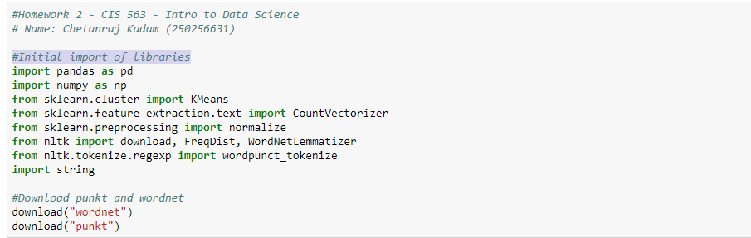

1. Place dataset in "foods.txt" in same folder of submitted iPython notebook.
2. Run all cells in iPython notebook and you will get result at the end.